Aim:

Transmit and receive digital signal using Binary Phase Shift Keying. **Apparatus:** Scientech ST2156, ST2157, Connecting Wires, DSO, Probes **Theory:**

Phase shift keying involves the phase change of the carrier wave between 0 and 180 in accordance with the data levels to be transmitted. Phase shift keying is also known as phase reversal keying (PRK). The PSK waveform for a given data is as shown in figure 1. For Binary PSK

S_0=A cos(wt)represents binary ‘0’ S_1=A cos(wt+p)represents binary ‘1’.

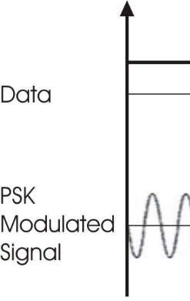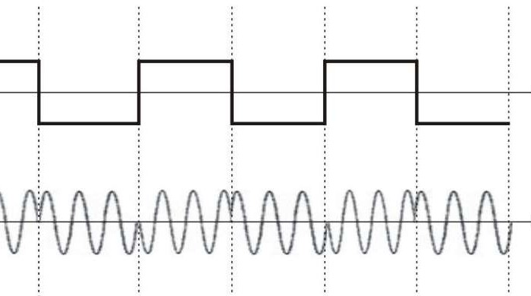

Figure 1. Phase Shift Keying Waveform

Functionally, the PSK modulator is very similar to the ASK modulator. Both uses

balanced modulator to

multiply the carrier with the modulating signal. But in contrast to ASK technique, the digital signal applied to the modulation input for PSK generation is bipolar i.e. have equal positive and negative voltage levels. When the modulating input is positive the output of modulator is a sine wave in phase with the carrier input. Whereas for the negative voltage levels, the output of modulator is a sine wave which is shifted out of phase by 180

from the carrier input. This happens because thecarrier input is now multiplied by the negative constant

level.. The functional block representation of the PSK modulator is shown in the figure 2.

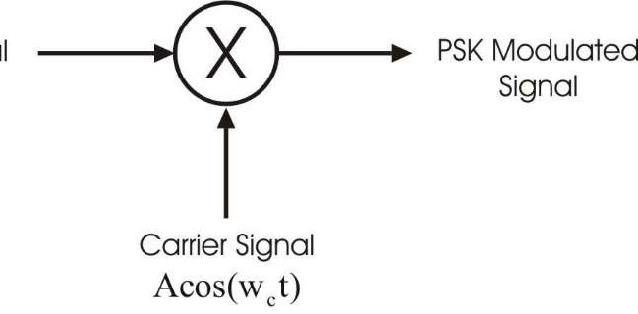

Figure 2. Phase Shift Keying Modulator

For PSK signal demodulation the square loop detector circuit is used. The PSK demodulator is as shown in figure 3.

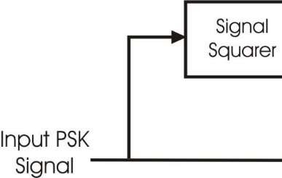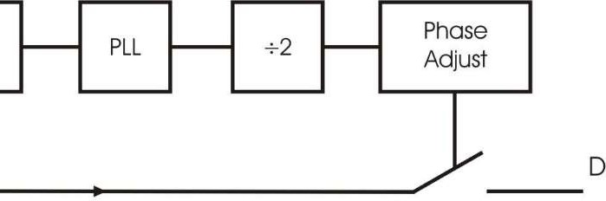

Figure 3. Phase Shift Keying Demodulator

The incoming PSK signal with 0 & 180 phase changes is first fed to the signal squarer, which multiplies the input signal by itself. The output of this block is a signal of having twice the frequency to that of the input carrier frequency. As the frequency of the output doubled, the 0 & 180 phase changes are reflect as 0 & 360 phase changes. Since phase change of 360 is same as 0 phase change, it can be said that the signal squarer simply removes the phase transitions from the original PSK waveform.

The PLL block locks to the frequency of the signal square output & produces a clean square wave output of same frequency. To derive the square wave of same frequency as the incoming PSK signal, the PLL output is divided by two.

The following phase adjust circuit allows the phase of the digital signal to be adjusted with respect to the input

PSK signal. Also its output controls the closing of an analog switch. When the output is high the switch closes

& the original PSK signal is switched through the detector. When the output of phases adjust block is low, the switch opens & the output of detector output falls to 0 Volts. The demodulator output contains positive half cycles when the PSK input has one phase & only negative half cycles when the PSK input has another phase. The phase adjust potentiometer is adjusted properly. The average level information of the demodulator output which contains the digital data information is extracted by the following low pass filter. The low pass filter output is too rounded to be used for digital processing. Therefore it is 'Squared Up' by a voltage comparator.

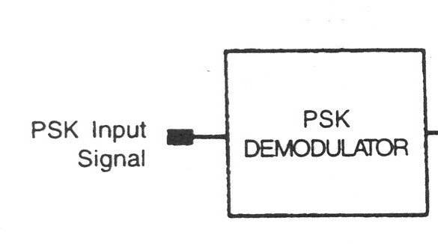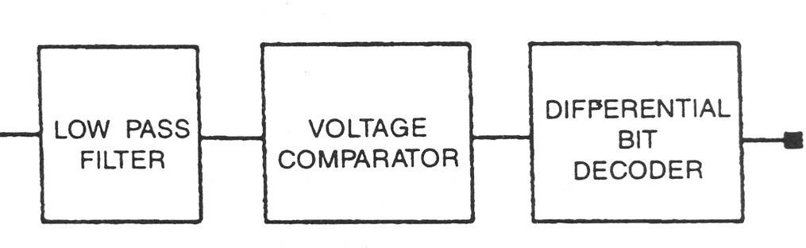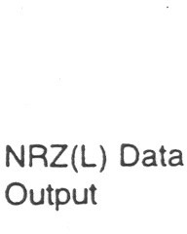

Figure 4. Phase Shift Keying Receiver System

Since the sine wave is symmetrical, the receiver has no way of detecting whether the incoming phase of the signal is 0 or 180 This phase ambiguity create two different possibilities for the receiver output i.e. the final

data stream can be either the original data stream or its inverse. This phase ambiguity can be corrected by

applying some data conditioning to the incoming stream to convert it to a form which recognizes the logic levels by changes that occur & not by the absolute value. One such code is NRZ (M) where a change or the absence of change conveys the information. A change in level represents data '1' & no change represents data '0'. This NRZ (M) waveform is used to change the phase at the modulator. The comparator output at receiver can again be of two forms, one being the logical inverse of the other. But now it is not the absolute value in which we are interested. Now the receiver simply locks for changes in levels, a level change representing a '1'

and no level changes representing a '0' thus the phase ambiguity problem does not make difference any more. This is known as differential phase shift keying. This process is known as differential encoding.

# Block Diagram:

**Simulink Diagram:**

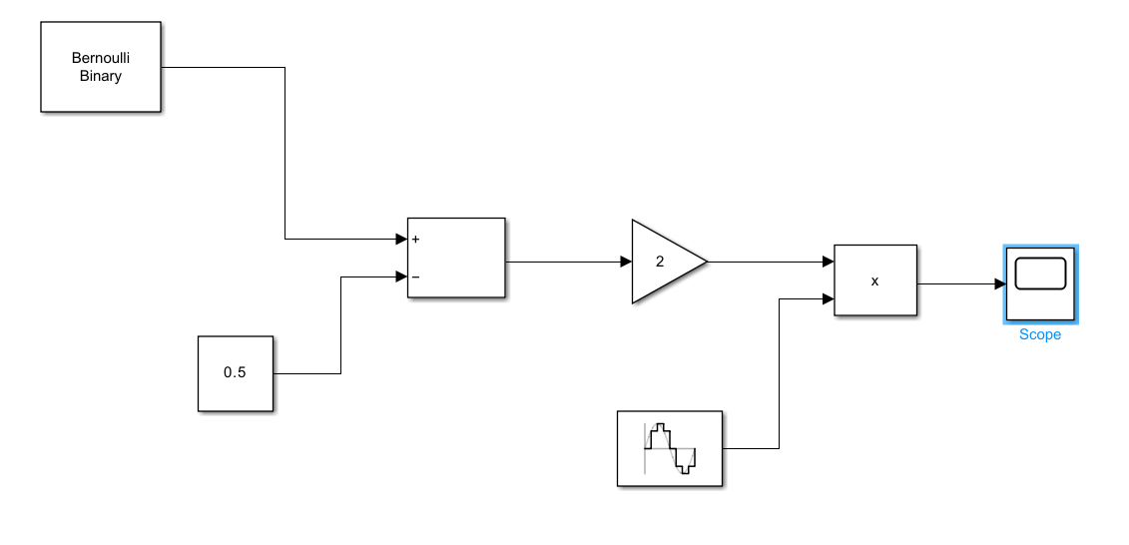

# Procedure:

Step-1

Step-2

1. Apply input signal (t.p. 4) to the modulation input of carrier modulation circuit (t.p. 27).
2. Apply the carrier signal (t.p. 18) from carrier generation circuit to carrier input of carrier modulation circuit (t.p. 26)
3. Observe the output (t.p. 28) on CRO screen and analyze the waveform
4. Change the carrier offset knob and observe the effect on output waveform on CRO.
5. Change the modulation offset knob and observe the effect on output waveform on CRO.
6. Change the gain knob and observe the effect on output waveform on CRO.
7. Apply input signal (t.p. 4) to the input of data inverter block (t.p. 32).
8. Apply the output of data inverter (t.p. 33) to the modulation input of carrier modulation circuit (t.p. 30).
9. Apply the carrier signal (t.p. 17) from carrier generation circuit to carrier input of carrier modulation circuit (t.p. 29)
10. Observe the output (t.p. 31) on CRO screen and analyze the waveform.

Step-3

Step-4

Step-5

1. Change the carrier offset knob and observe the effect on output waveform on CRO.
2. Change the modulation offset knob and observe the effect on output waveform on CRO.
3. Change the gain knob and observe the effect on output waveform on CRO.
4. Apply the output of t.p 28 and t.p. 31 to the input A and input B respectively of the summing amplifier.
5. Observe the FSK waveform at output of amplifier at t.p. 36
6. For demodulating the signal, apply the output of modulator kit t.p. 36 to the PSK demodulator kit input at t.p. 10 of trainer kit ST2157.
7. Set the carrier frequency to 960 KHz option.
8. Connect the output of demodulator (t.p. 15) to low pass filter at t.p. 23.
9. Connect the output of filter t.p. 24 to the data squaring circuit input at tp. 46.
10. Set the comparator threshold by changing knob if required.
11. Observe the demodulated output at t.p. 46

Design Simulink model for BPSK and observe signals and constellation diagram.

# Conclusion:

**Post Lab Exercise:**

* 1. What is constellation diagram? Explain with diagram.
  2. List applications of BPSK.
  3. Write equation for BER and sketch BER performance curve for BPSK.